PUBLIC BIN INVESTMENT PROGRAMME (PBIP) – AUGUST 2021

Earlier this year, a report was presented to Environment Committee proposing improvements to the current provision of litter bins across the city and introducing more public recycling bins. The Committee resolved that officers would work with Members and produce Ward level action plans. These plans, to be fully costed up, would be brought back to the November meeting of the Committee. Implementation of the improvements is projected to last until March 2025.

The proposals for every Ward are based on evaluations and assessment of:

- Existing locations and bin capacity.
- Requirement for additional locations and more capacity.
- Consolidation of multiple bins at single locations (whilst maintaining/increasing capacity).
- Phasing out of old stock such as open-topped bins.
- City image and user experience.
- Expansion of ‘Recycling on the Go’.

A budget has been made available in advance of approving the main scheme which allows for specific locations to be improved and for additional locations to be added to resolve immediate problems. This is known as Phase One. The priority for improvement has been agreed as consolidation of multiple bins in one location and bins provided in new locations.

This document includes:

1. Proposed details of the Phase One implementation.
2. A plan of all current locations and bin types.
3. A plan of all proposed locations and bin types.

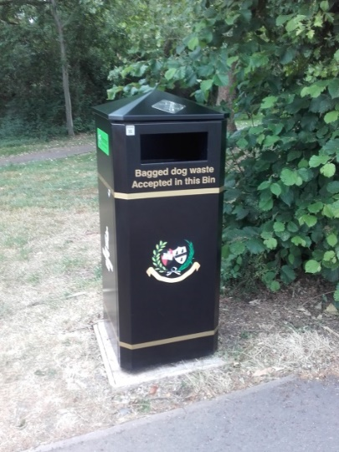
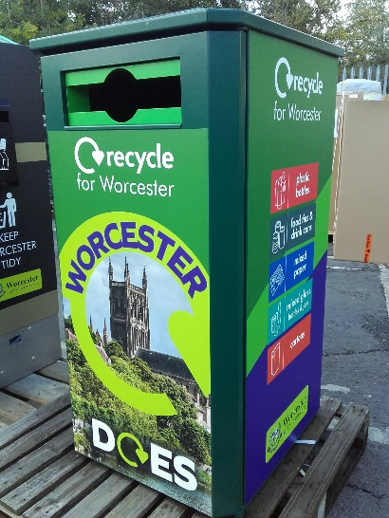
Please note that the styles of bin to be purchased are wheelie bin housings (WBH) containing either a 140 litre or 240 litre wheelie bin.

The ‘black’ version will accept both litter and dog waste.

The green bin accepts the same recyclables as for household recycling.

These locations have been assessed as having multiple bins in the same place so are proposed to be in Phase One of the implementation programme. Any new locations proposed will be shown at the bottom of the list.

Single locations with multiple bins have been assessed as:
• Bins which are immediately adjacent to each other
• Bins which are clearly visible and easily accessible from each other, e.g. 2 bins each side of a play area, or 2 bins on opposite sides of a minor road.

BATTENHALL WARD – PBIP Phase 1
Location | Current provision  (to be removed) | Capacity (litres) | Phase 1 provision  (to be installed) | Capacity (litres)
BATH ROAD Duck Brook ent & adj. BS | 1x dog waste bin  1x small litter bin | 40  35 | Wheelie bin housing | 240
BATTENHALL ROAD O/S No.72 Adj. Evendine Close | 1x dog waste bin  1x WBH 140 | 40  140 | Wheelie bin housing | 240
CROMWELL CRESCENT PARK (main ent.) | 2x dog waste bin | 80 | Wheelie bin housing | 240
CROMWELL CRESCENT PARK (Foxwell ent.) | 2x dog waste bin | 80 | Wheelie bin housing | 240
FIELD WALK play area & rec. ground | 2x dog waste bin | 80 | Wheelie bin housing | 240
SPRINGFIELD ROAD FP adj. play area | 1x dog waste bin  1x small litter bin | 40  35 | Wheelie bin housing | 240
ST DUNSTANS CLOSE rec. ground | 2x dog waste bin  1X small litter bin | 80  35 | Wheelie bin housing | 240
TIMBERDINE AVENUE Adj. Battenhall Road Jnc. | 2x small litter bin | 70 | Wheelie bin housing | 140
BATTENHALL ROAD FP to Evendine Cl. | New | 0 | Wheelie bin housing | 140
Total | 17 | 755 | 9 | 1960

Multi-location at Cromwell Crescent play area with, current, sufficient capacity will be addressed in a future Phase.

The following plan shows all the current locations and bin types plus those close-by in adjacent wards (coloured yellow).
Battenhall Ward - Current total bin provision
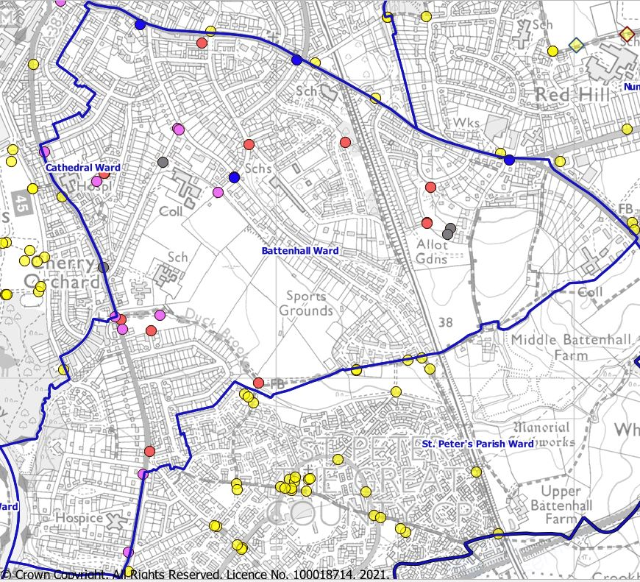 | Total bin locations = 23  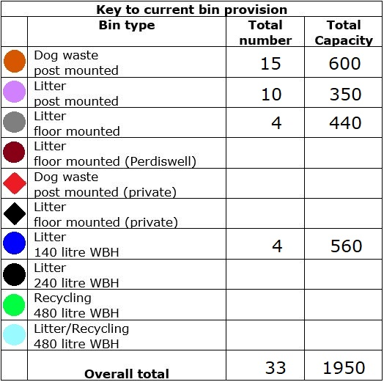
The mapping scale level means that you may not be able to discern all bins at locations with multiple bins.
Bins highlighted yellow in adjacent Wards may also serve Ward constituents.

The following plan shows all the proposed locations and bin types for implementation in phases up to March 2025.
Battenhall Ward - Proposed bin provision
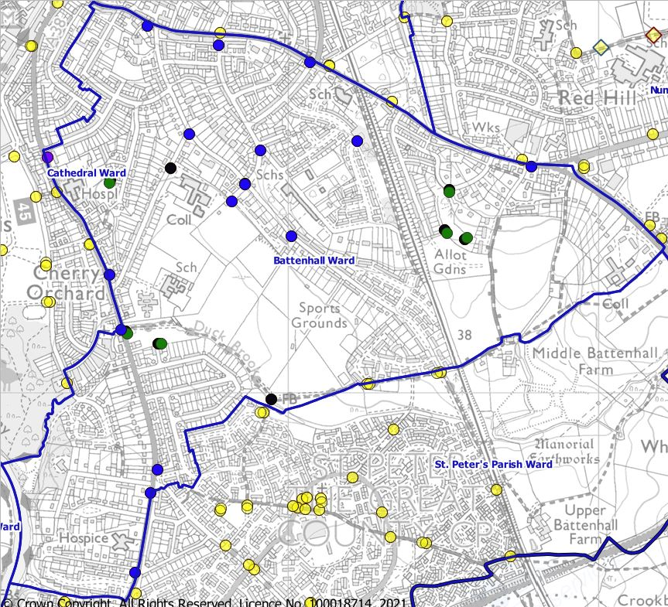 | Total bin locations = 24  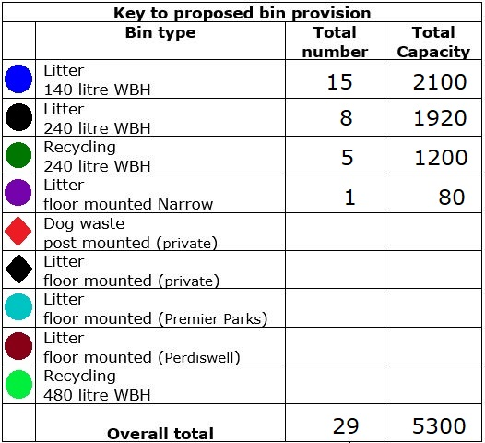
The mapping scale level means that you may not be able to discern all recycling/residual waste bins at locations where they are partnered. Bins highlighted yellow in adjacent Wards may also serve Ward constituents.

